Assignment8
1. Explain what a critical value is, and explain how it is used to test a hypothesis.

A rejection point is a point on the horizontal axis under the standard normal curve that defines an area equal to , the probability of making a Type I error.

2. Explain what a p-value is, and explain how it is used to test a hypothesis.

A p-value is the probability that we obtain a sample statistic that contradicts the null hypothesis as much as or more than the observed sample statistic.

3. THE CAR MILEAGE CASE
Suppose the federal government proposes to give a substantial tax break to automakers producing midsize cars that get a mean mileage exceeding 31 mpg. Letting  be a midsize car’s mean mileage, the government will award the tax credit if an automaker is able to reject 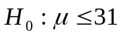 in favour of 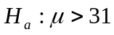 at the .05 level of significance. Recall that the sample of 49 mileages has mean 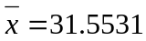. Assuming that equals 0.8, use these sample results and a rejection point to test the null hypothesis versus the alternative hypothesis at the 0.05 level of significance . Will the automaker be awarded the tax break? Calculate p value. Would the tax break have been awarded if the federal government had set equal to 0.01? Justify your answer.

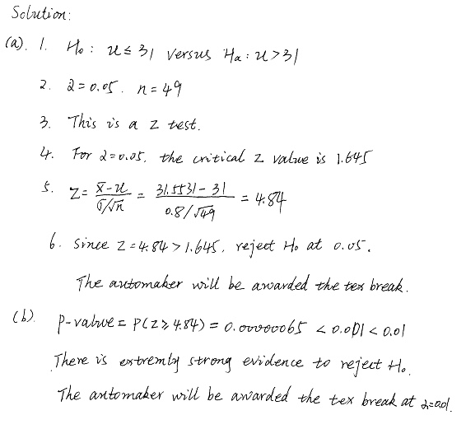
4. In recent years the interest rate on home mortgages has declined to less than 6.0 percent. However, according to a study by Federal Reserve Board the rate charge on credit card debit is more than 14 percent. Listed below is the interest rate charged on a sample of 10 credit cards.
14.6 16.7 17.4 17.0 17.8 15.4 13.1 15.8 14.3 14.5
Is it reasonable to conclude the mean rate charged is greater than 14 percent? Use the 0.01 significance level.

4.
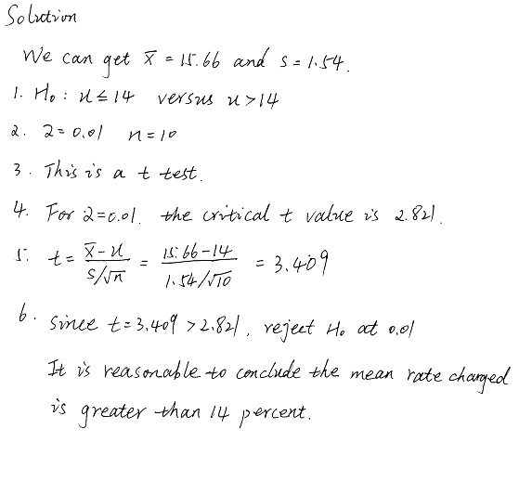

5. The Watch Corporation of Switzerland claims that their watches on average will neither gain nor lose time during a week. A sample of 18 watches provided the following gains(+) or losses(-) in seconds per week.
-0.38 -0.20 -0.38 -0.32 +0.32 -0.23 +0.30 +0.25 -0.10 -0.37 -0.61 -0.48 -0.47 -0.64 -0.04 -0.20
-0.68 +0.05
Is it reasonable to conclude the mean gain or loss in time for the watches is 0? Use the 0.05 significance level. Estimate the p-value.

5.
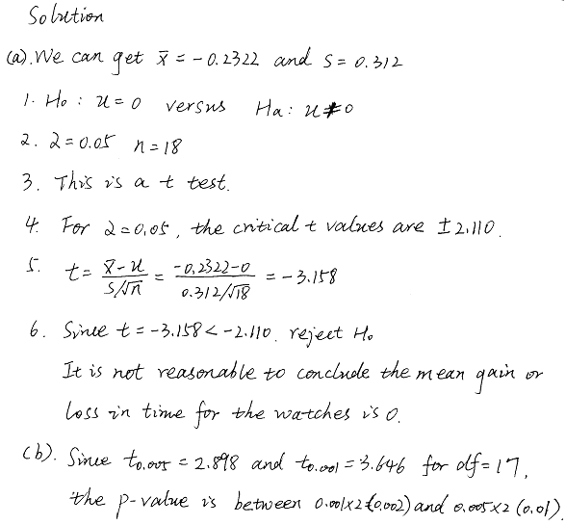

6. An urban planner claims that, nationally, 20 percent of all families renting condominiums move during a given year. A random sample of 200 families renting condominiums in Dallas Metroplex reveal that 56 had moved during the past year. At the 0.1 significance level, does this evidence suggest that a large proportion of condominium owners moved in the Dallas area? Determine the p-value.

